SURVEY FOR EDUCATORS

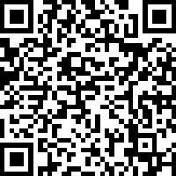

SURVEY FOR STUDENTS

